NIH Pay.Gov User Guide
(Sale of Research Substances Collections)
Version 1.0
March 2018

Version History
Version  Number | Implemented  By | Revision  Date | Approved  By | Approval  Date | Description of  Change
1.0 | RemedyBiz,Inc. | 03/01/2018

Contents
Processing Payments for Sale of Research Substances through Pay.Gov 3
Part I: Initial Contract / Invoice Form 3
Part II: Payment Options 5
Option A: Bank Account (ACH) 5
Option B: Amazon Account 7
Option C: PayPal Account 8
Option D: Debit or Credit Card 10
Appendix A: Payment Limits 12
Credit Cards 12
Debit Cards 12
Bank Accounts for ACH Debit or Credit 12
Amazon Pay 12
PayPal 12

Processing Payments for Sale of Research Substances through Pay.Gov

Part I: Initial Contract / Invoice Form

Step #1: This initial screen shows the acceptable payment methods.
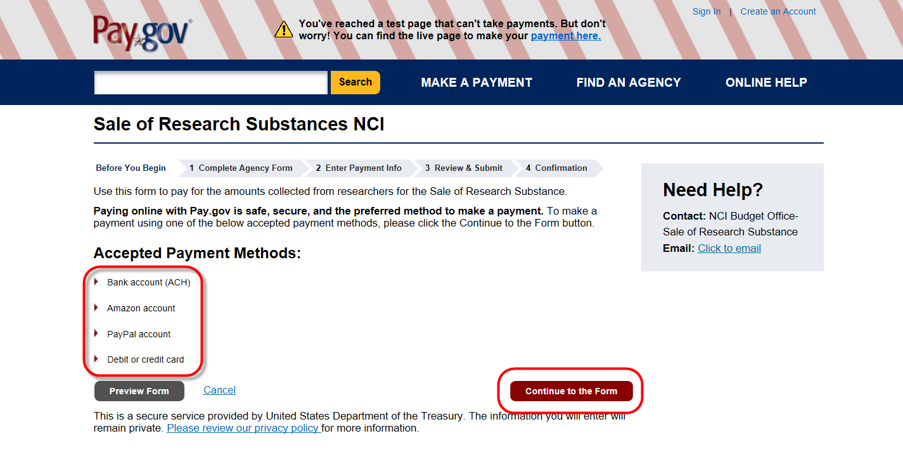
Click “Continue to the Form” to proceed.

Step #2: Enter information such as the contractor details, contract/invoice detail, etc. in this form. 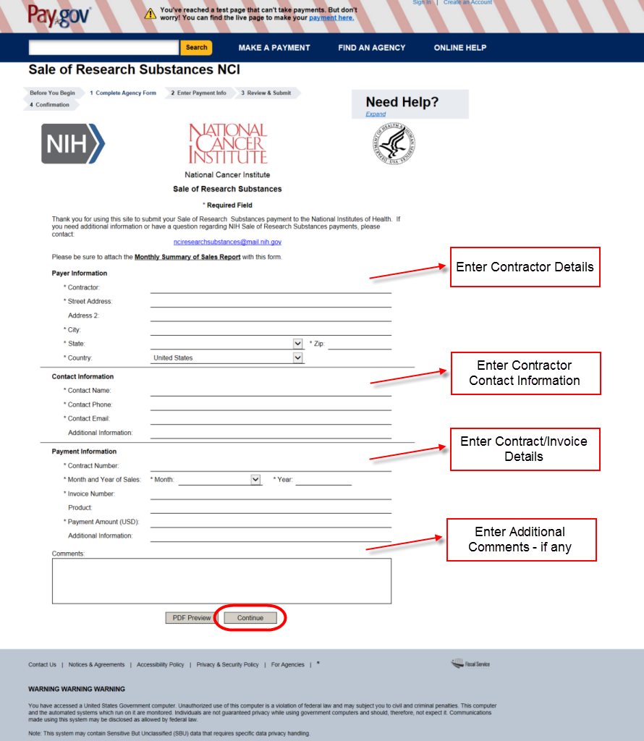
Once the fields are entered correctly, click “Continue” to proceed.

Step #3: Any supporting documents (reports, invoices etc.) should be attached during this step.
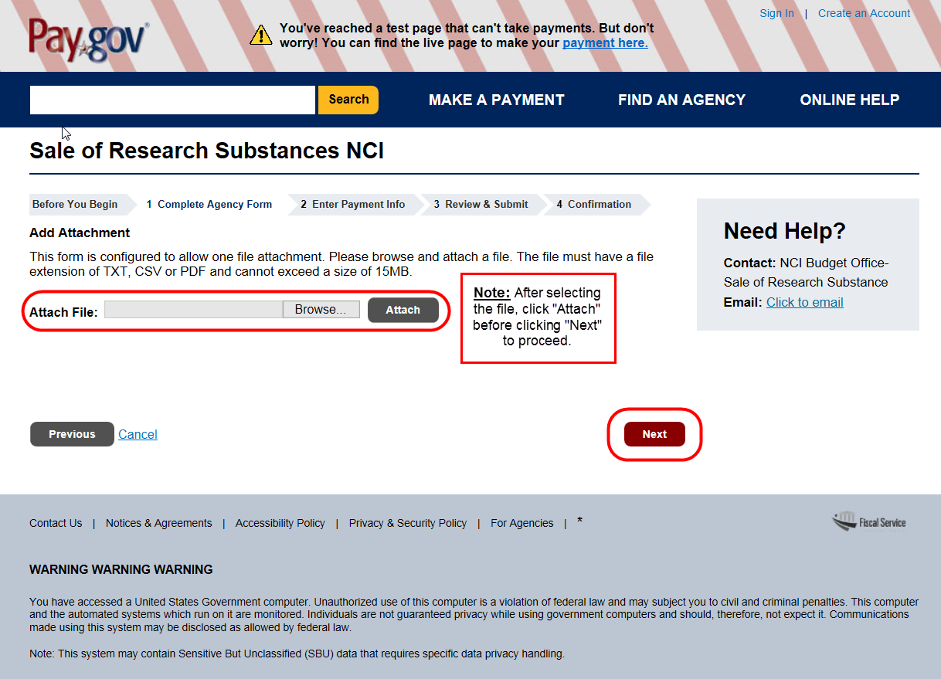
Step #4: If no supporting documentation is attached, this warning message will appear. Be sure to upload all supporting documents before moving forward.
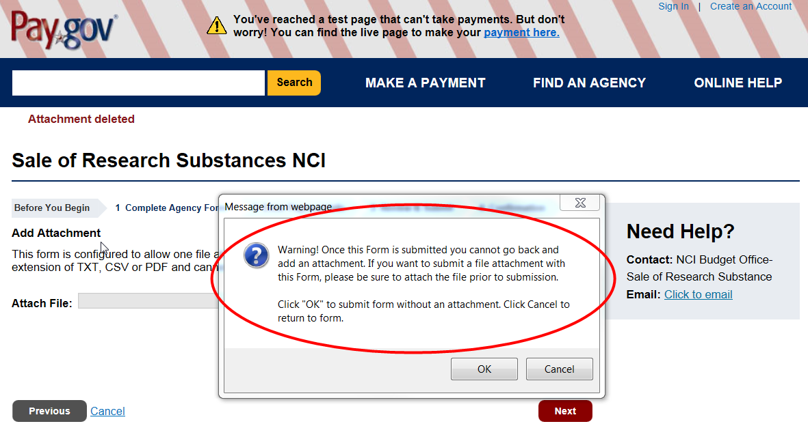

Part II: Payment Options

Option A: Bank Account (ACH)

Step #5: Select the “Bank account (ACH)” payment method in this screen.
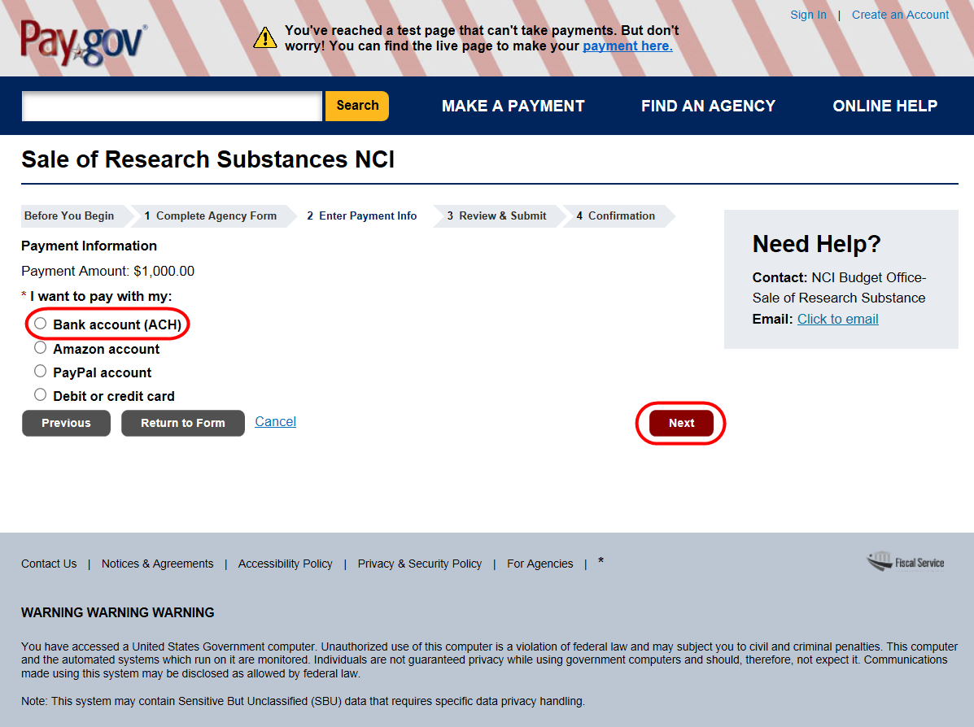
Step #6: Enter all Bank Account (ACH) details in this form. (Refer to Appendix A for Payment Limits).
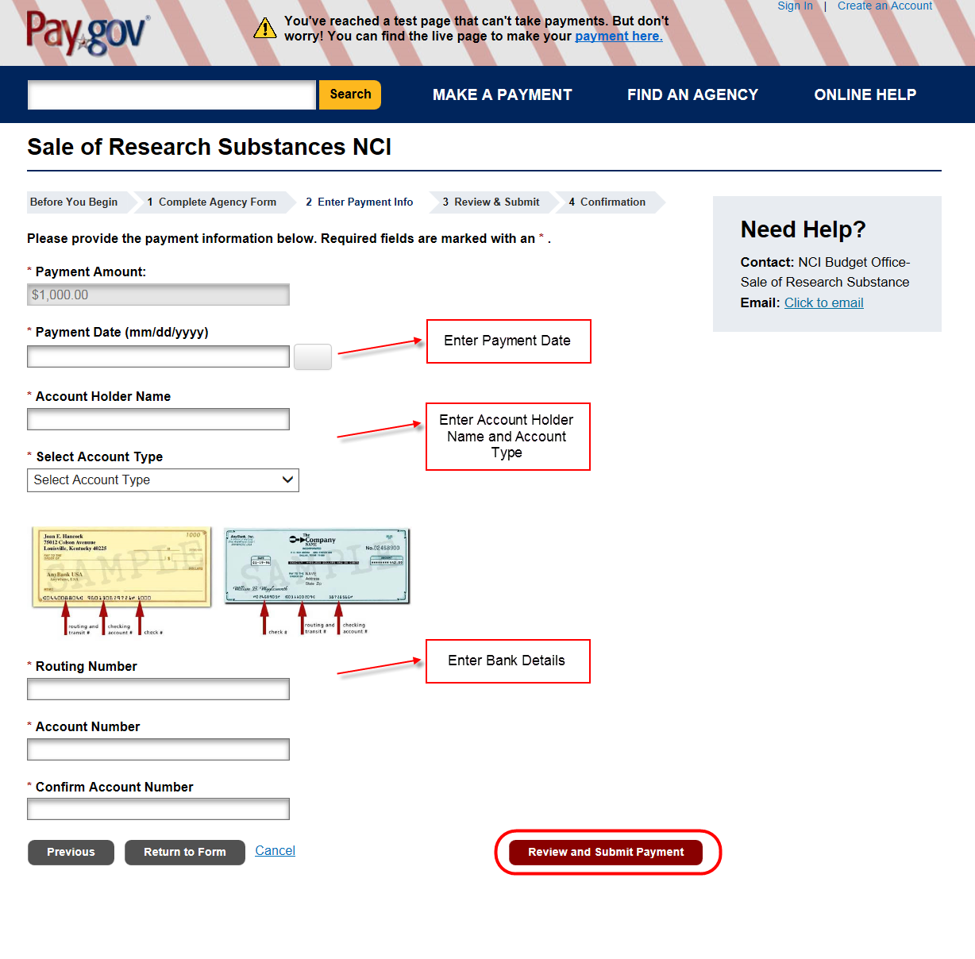

Step #7: Select this option and enter a valid email address to receive the transaction confirmation.
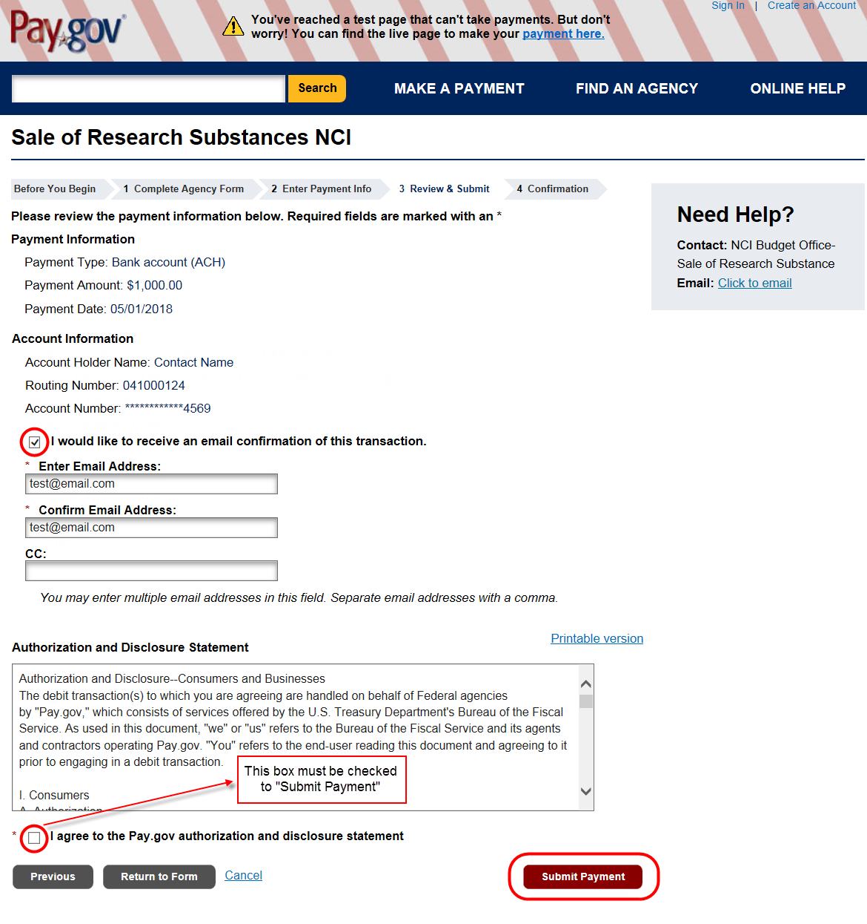

Option B: Amazon Account

Step #5: Select the “Amazon account” payment method in this screen.
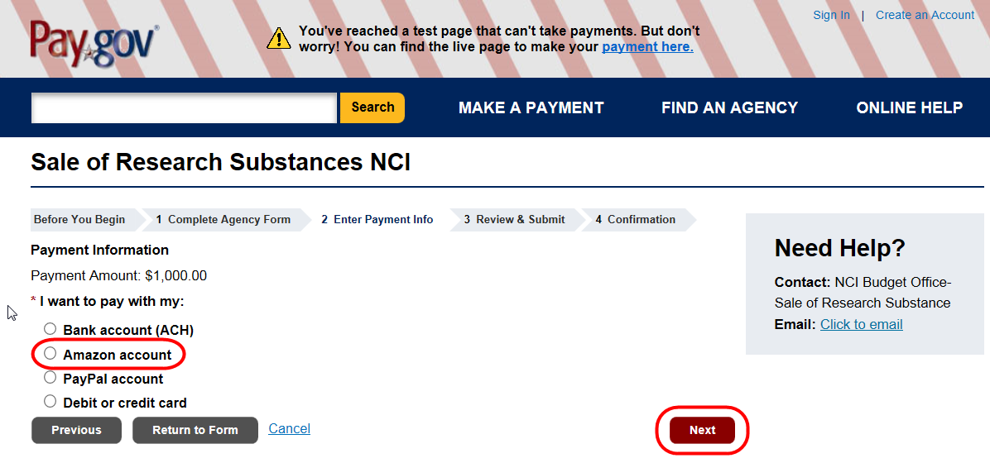
Step #6: Complete the remaining payment process using the external website. (Refer to Appendix A for Payment Limits)
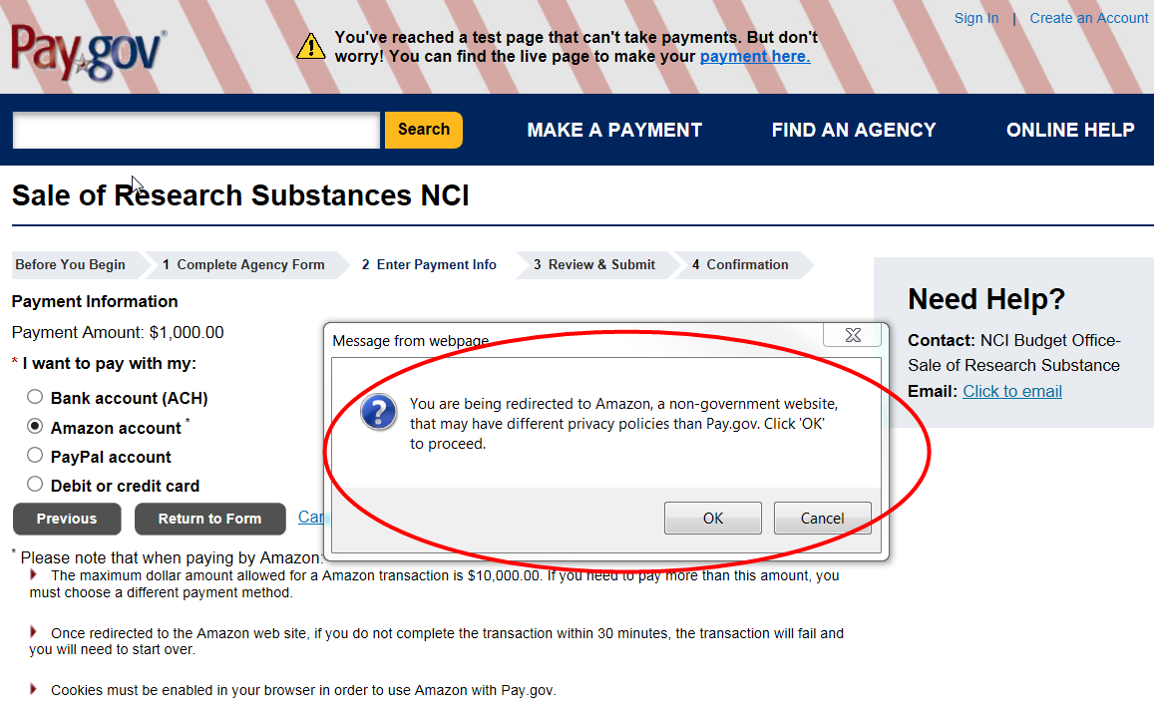
Step #7: Select this option and enter a valid email address to receive the transaction confirmation.
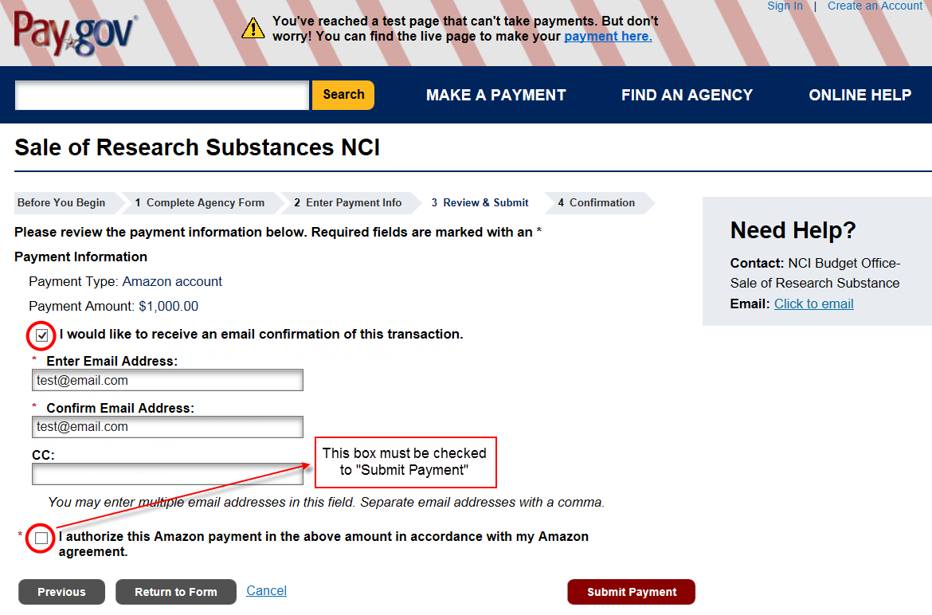

Option C: PayPal Account

Step #5: Select the “PayPal account” payment method in this screen.

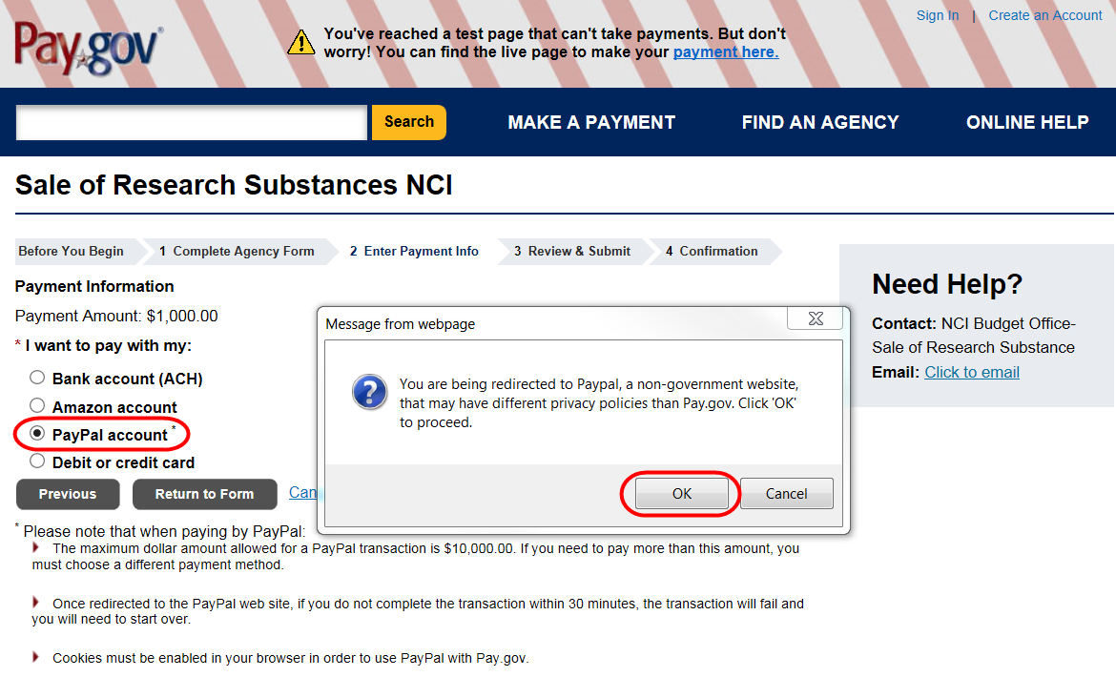

Step: #6: Complete the remaining payment process using the external website. (Refer to Appendix A for Payment Limits)

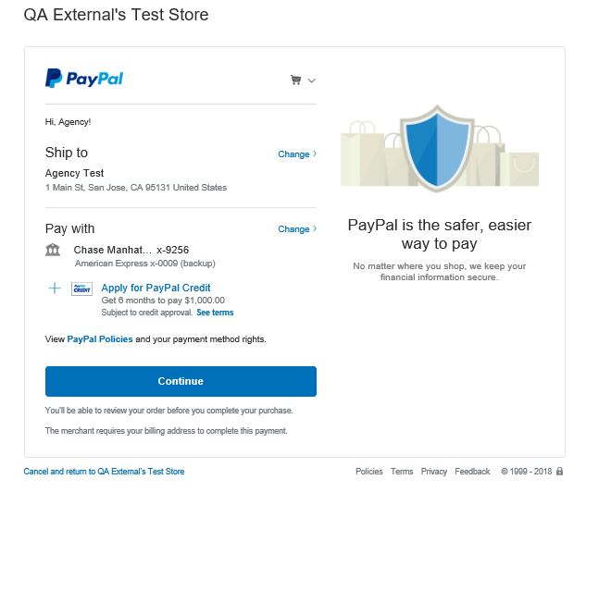

Step #7: Select this option and enter a valid email address to receive the transaction confirmation.
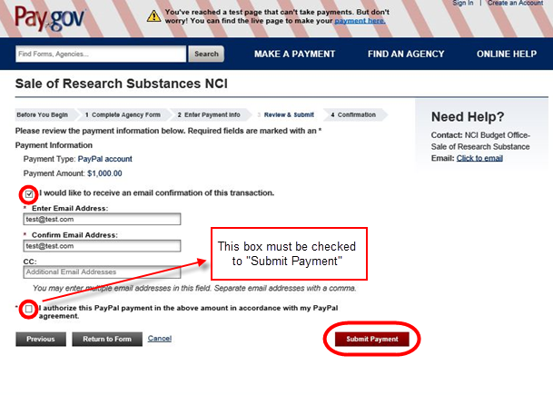

Option D: Debit or Credit Card

Step #5: Select the “Debit or credit card” payment method in this screen.
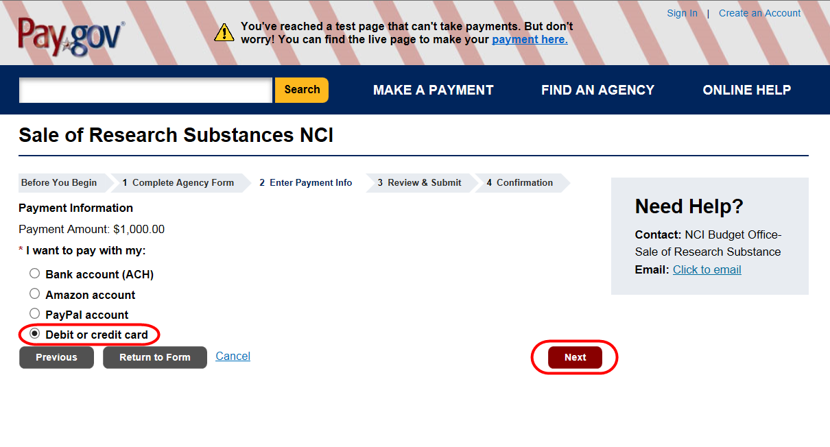
Step #6: Enter the amount and credit or debit card details. (Refer to Appendix A for Payment Limits)
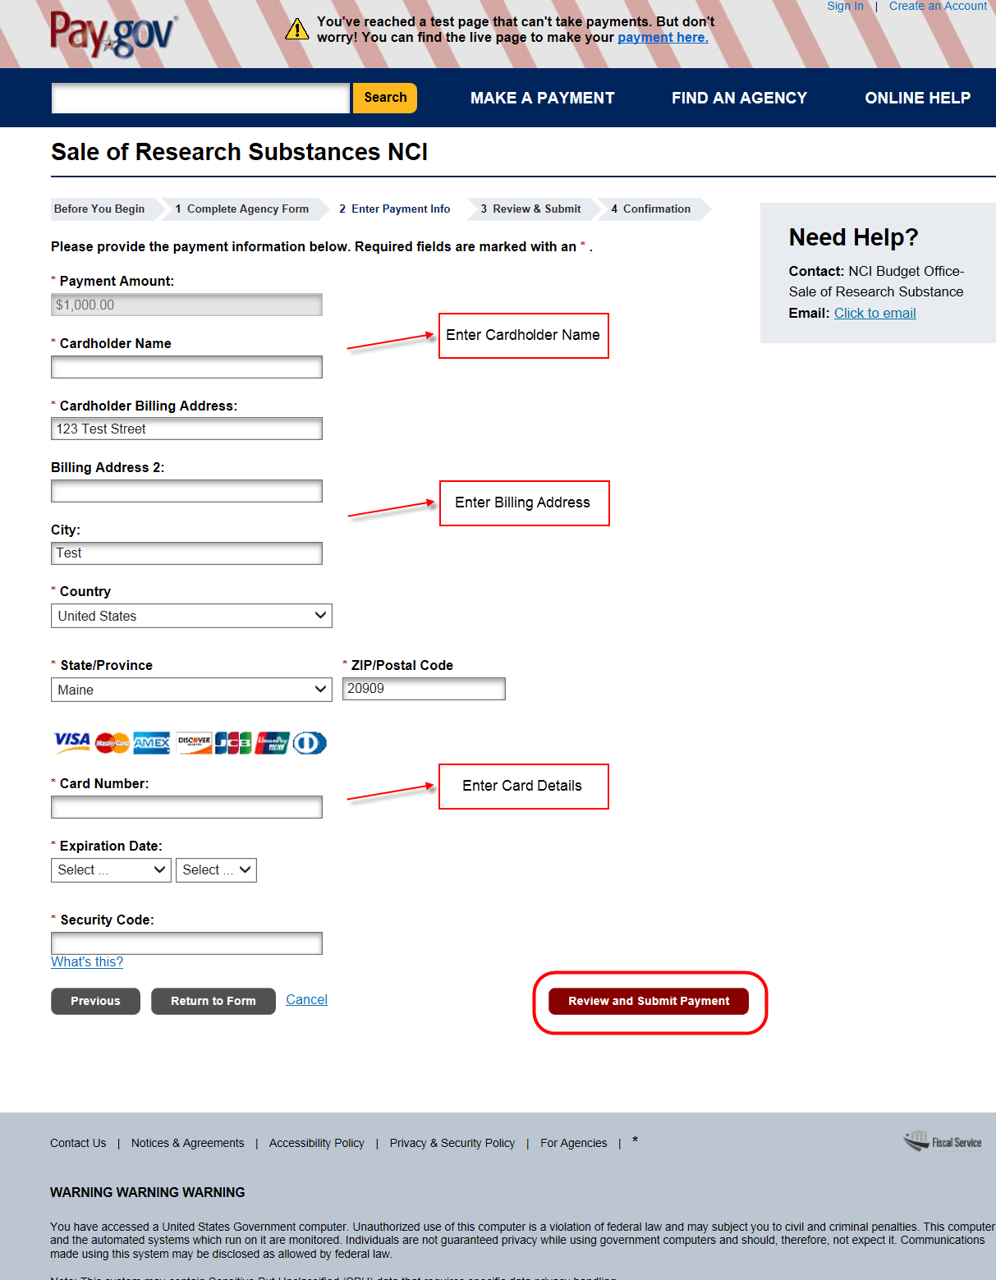

Step #7: Select this option and enter a valid email address to receive the transaction confirmation.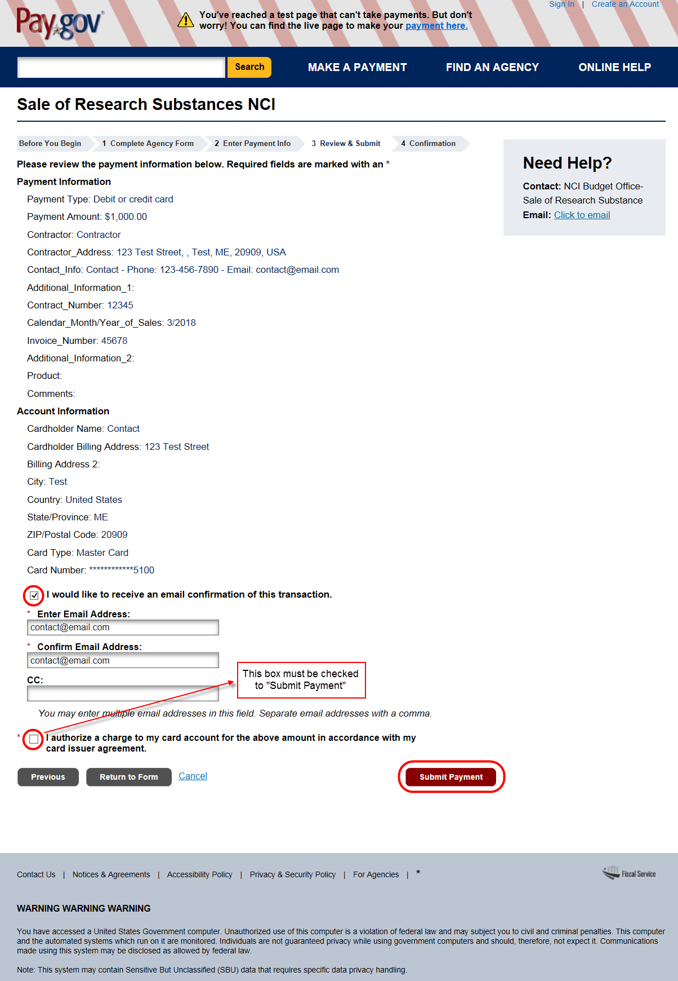

Appendix A: Payment Limits
(Please refer to Pay.Gov Help - https://pay.gov/WebHelp/HTML/payments_limits.html)
These are the limits set in Pay.gov. Your bank or the agency being paid may have a lower limit.

Credit Cards
- Up to a total of $24,999.99 for all transactions with one or more U.S. Government agencies conducted on the same day using the same credit card. The total could combine payments made on Pay.gov and payments made any other way, such as presenting or swiping the card directly at an agency office.
Example: On a Thursday, the same credit card is used for three separate payments of $10,000 each. Two payments were made on Pay.gov. The third payment, made directly to an agency, will be rejected because the total of all payments made with the credit card is over the daily limit. You could, however, use a different credit card for the third payment.
- You may not split payments using the same card if the total will be over the limit, even if partial payments are made on different days.
Example: You must pay a fee of $35,000. You decide to make two partial payments using the same credit card. On Thursday you pay $20,000. On Friday, you pay the remaining $15,000. Because both payments are for the same fee, the same card was used and the total of both payments is over the limit, Friday's payment will be rejected. You could use a different credit card for each partial payment.

Debit Cards
- No limit except for the funds available in your account.

Bank Accounts for ACH Debit or Credit
- Up to $99,999.999.99 per transaction, limited by the funds available in the account.

Amazon Pay
- Up to $10,000 per transaction. You can make multiple transactions, which are only limited by the funds available to your Dollar account.

PayPal
- Up to $10,000 per transaction. You can make multiple transactions, which are only limited by the funds available to your PayPal account

